# **Transaction fees and Gas used:**

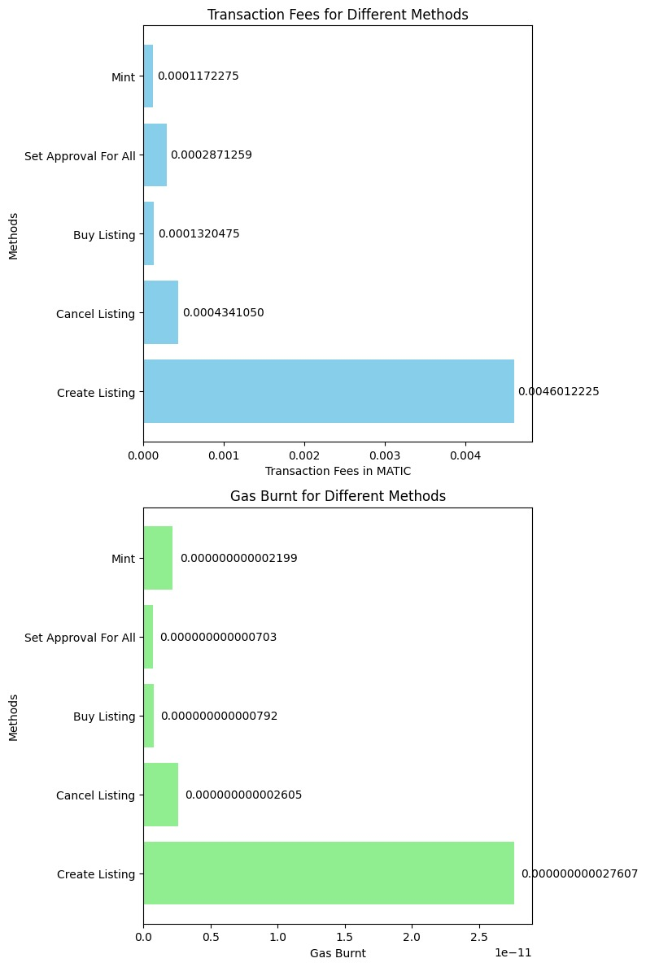

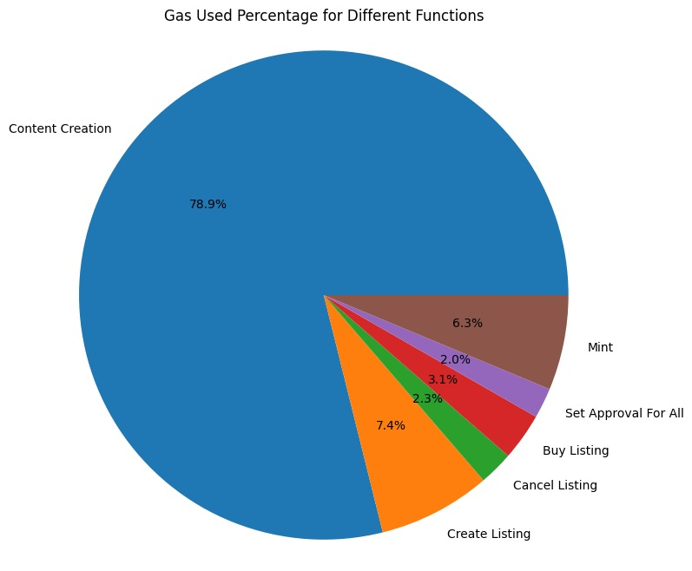

**Content Creation:**

The transaction fee for content creation is 0.004601222527607335 MATIC, with a gas limit of 1,840,489 and usage at 100%. This high transaction fee and gas usage suggest a potentially intricate process, possibly involving extensive validations or complex operations. This reflects a substantial requirement of network resources and computational steps.

**Create Listing:**

For creating a listing, the transaction fee is 0.00043410500260463 MATIC, with a gas limit of 173,642 utilized at 100%. This lower transaction fee and gas usage imply a comparatively simpler process than content creation. Creating a listing might involve fewer computational steps and validation checks, impacting resource consumption.

**Cancel Listing:**

The transaction fee when canceling a listing is 0.000132047500792285 MATIC, with a gas limit of 52,819 used at 100%. These notably lower fees and gas usage suggest a straightforward and efficient operation, indicating minimal resource consumption and computational overhead.

**Buy Listing:**

The transaction fee for buying a listing stands at 0.000287125891221442 MATIC, with a gas limit of 72,818 utilized at 96.15%. This moderate to high fee and gas usage imply significant network resources and computations, likely due to multiple validations, fund transfers, and confirmations.

**Set Approval For All:**

The transaction fee for setting global approvals is 0.000117227500703365 MATIC, with a gas limit of 46,891 used at 100%. This function demonstrates relatively low fees and gas usage, indicating a streamlined and efficient process with minimal resource consumption.

**Mint:**

Minting bears a transaction fee of 0.00036651000219906 MATIC, with a gas limit of 146,604 utilized at 100%. This moderate fee suggests a moderately complex process involving token creation and allocation.

Regarding independent and dependent variables, the different functions (Content Creation, Create Listing, etc.) act as independent variables, while transaction fees and gas usage function as dependent variables influenced by factors like gas limits, network conditions, and smart contract configurations. These variables showcase varying behaviors due to the complexity of operations within each function and their corresponding resource requirements.

Linear and nonlinear behaviors are apparent across these functions. Linear behavior correlates transaction fees and gas usage with the complexity of operations. Nonlinear behavior could arise from unexpected complexities or optimizations in implementations, deviating from a straightforward relationship between the function and transaction metrics. This could also be due to external factors impacting transaction behavior, creating more intricate relationships.

# **TRANSACTION TIME :**

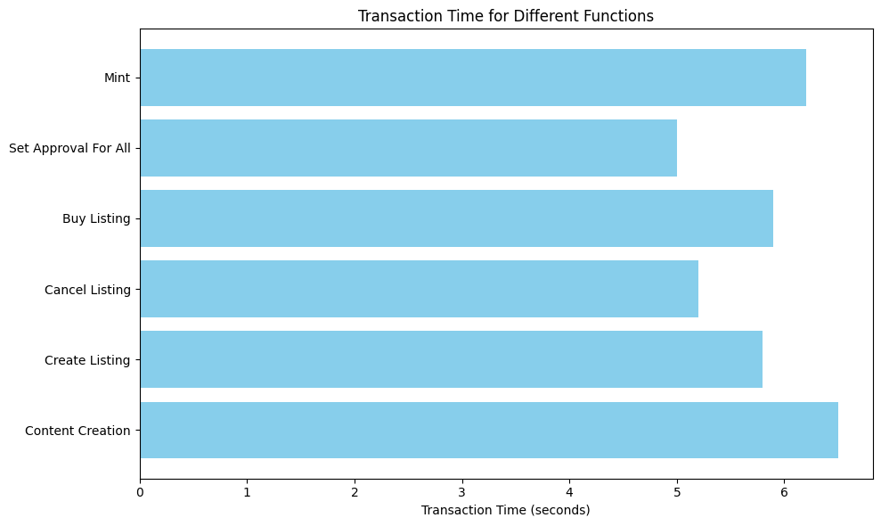

Transaction time represents the duration it takes for a specific function or transaction type to execute on the blockchain.

1. **Content Creation:**

- Transaction Time: 6.5 seconds

- This function might involve complex operations or require multiple steps, potentially due to the creation of content involving various data manipulations or storage actions. The longer transaction time could imply more intricate processing.

**2. Create Listing:**

- Transaction Time: 5.8 seconds

- Creating a listing appears slightly quicker than content creation, suggesting that this operation involves fewer steps or less complexity. It might involve setting up specific parameters for listing creation.

**3. Cancel Listing:**

- Transaction Time: 5.2 seconds

- Canceling a listing seems relatively fast compared to the creation process, indicating it involves fewer steps or less computational work. It might simply involve updating or removing an existing entry.

**4. Buy Listing:**

- Transaction Time: 5.9 seconds

- Buying a listing involves financial transactions and might need validation and confirmation steps. It's relatively close in time to content creation, indicating potential complexity due to financial transfers or validations.

**5. Set Approval For All:**

- Transaction Time: 5.0 seconds

- This action seems to be the quickest, indicating it might involve minimal computational work or validation steps. It might involve setting global permissions or approvals.

**6. Mint:**

- Transaction Time: 6.2 seconds

- Minting involves the creation of new tokens or assets. It's slightly longer in duration, suggesting it might require additional validation or more complex token generation processes.

# **Gasless Minting as a Metric:**

1. **Enhanced Accessibility:** Gasless minting extends accessibility, enabling users to interact with the platform without the barrier of transaction fees.

2. **User-Friendly Experience**: Eliminates the need for users to hold ETH or navigate complex gas settings, ensuring a seamless and intuitive experience.

3. **Increased User Adoption:** Lowers the entry barrier, attracting more users to engage, mint, or participate without incurring transaction costs, driving higher adoption rates.

4. **Cost-Efficient Transactions:** Facilitates cost-efficient transactions, particularly beneficial for microtransactions or token-based activities, promoting frequent user engagement.

5. **Boosts Engagement and Retention:** Encourages increased participation and prolonged user engagement by removing the financial friction associated with gas fees.

6. **Community-Centric Approach:** Fosters a community-centric ecosystem, promoting inclusivity and participation from users who might be deterred by transaction fees.

7. **Economic Incentives:** Drives user retention and loyalty by providing incentives to holders or frequent participants through gasless interactions, fostering a robust user community.

# **Token Gating as a Metric:**

1. **Enhanced Security Measures:** Token gating fortifies the platform's security, ensuring that users meet specific criteria or hold tokens to access certain functionalities or benefits.

2. **Community Involvement:** Encourages community involvement and governance by rewarding token holders with exclusive privileges, incentivizing long-term engagement and ownership.

3. **Monetization Strategy:** Provides an effective monetization model by tokenizing access or features, creating value for token holders and potentially generating revenue streams for the platform.

4. **Curated Access Levels:** Offers different tiers or levels of access based on token ownership, providing curated experiences for users based on their commitment or investment in the platform.

5. **Incentivized Participation:** Motivates users to hold or acquire tokens, driving engagement and active participation to unlock additional functionalities or exclusive content.

6**. Fair Distribution:** Ensures a fair distribution of access or benefits based on token ownership, promoting inclusivity and rewarding loyal community members.

7. **Deters Spam and Misuse:** Acts as a barrier against spam or misuse, requiring a genuine commitment from users to participate, contributing to a cleaner, more engaged user base.

## 

## 

## 

## **RESULTS : (SCREENSHOTS)**

Welcome to the versatile frontend interface designed to seamlessly integrate with various extensions like Coinbase and MetaMask, among others.

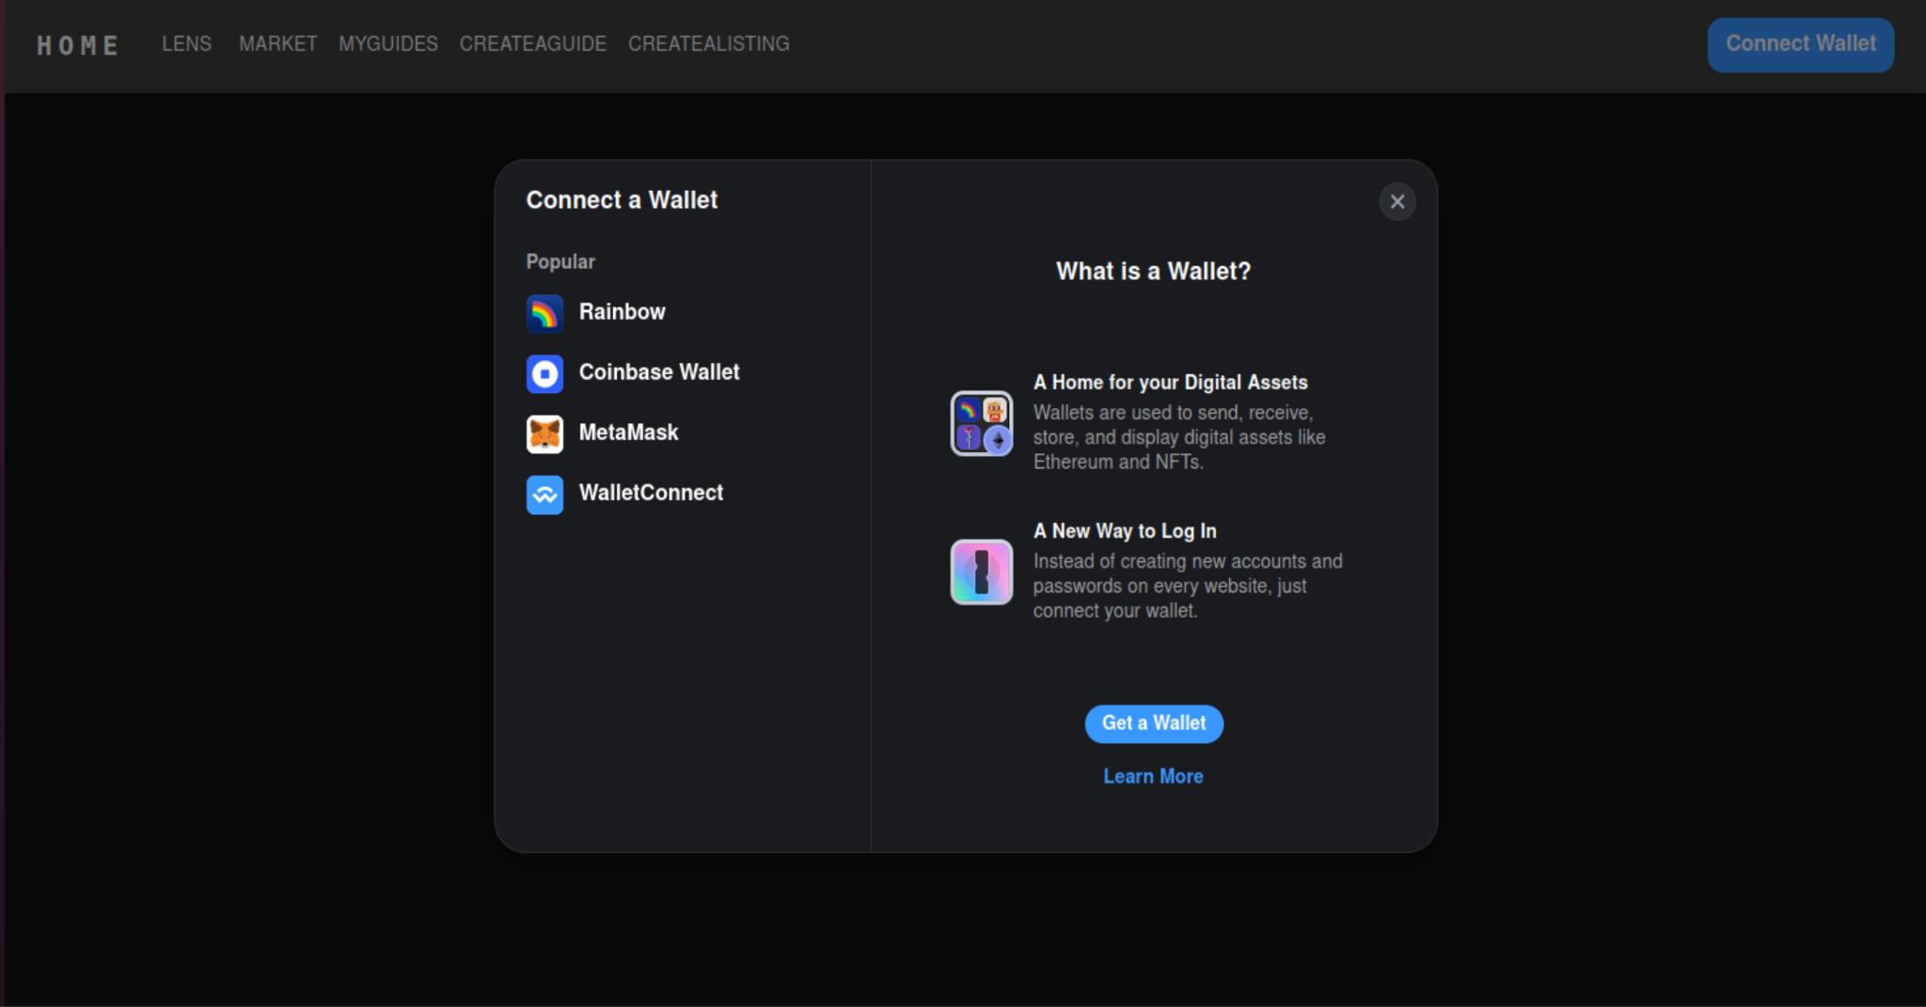

# 

# **User flow:**

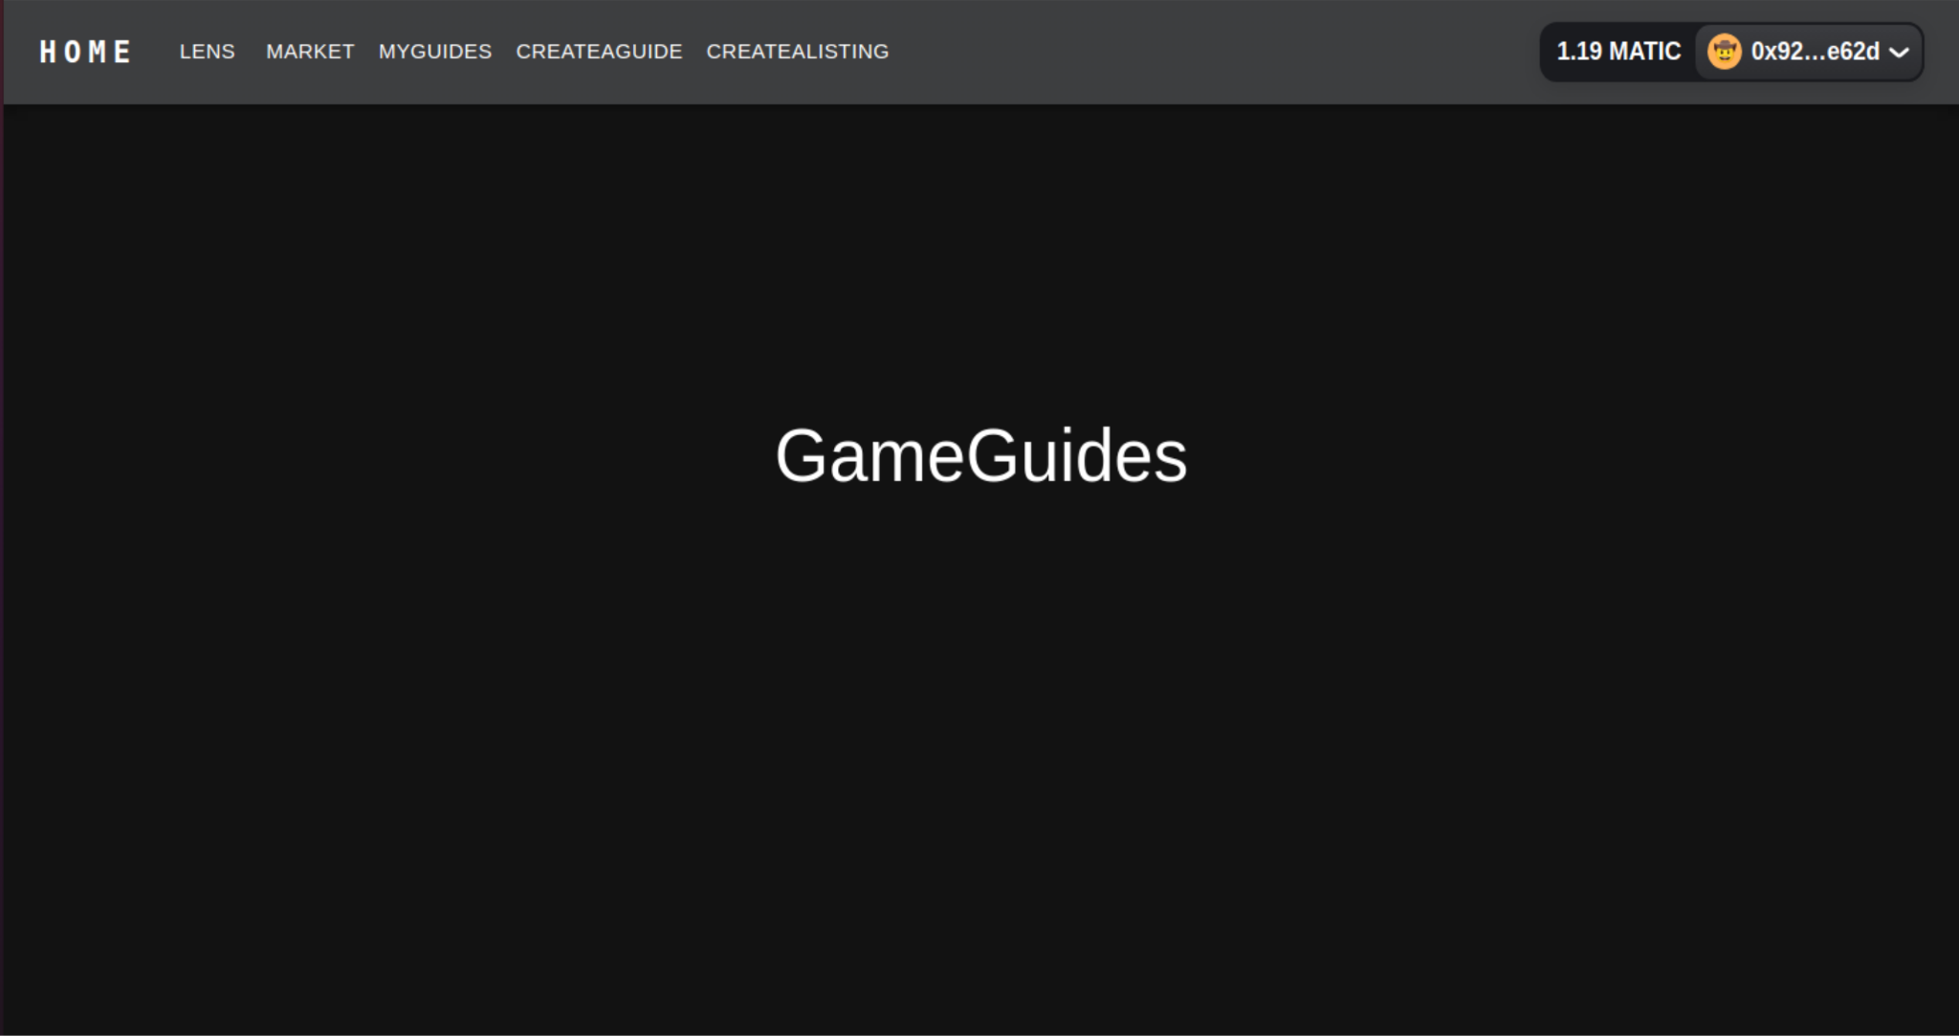

Designed an intuitive interface where users can input details for creating guides or listings. This might include fields for title, description, category, images, pricing, and any other relevant information.

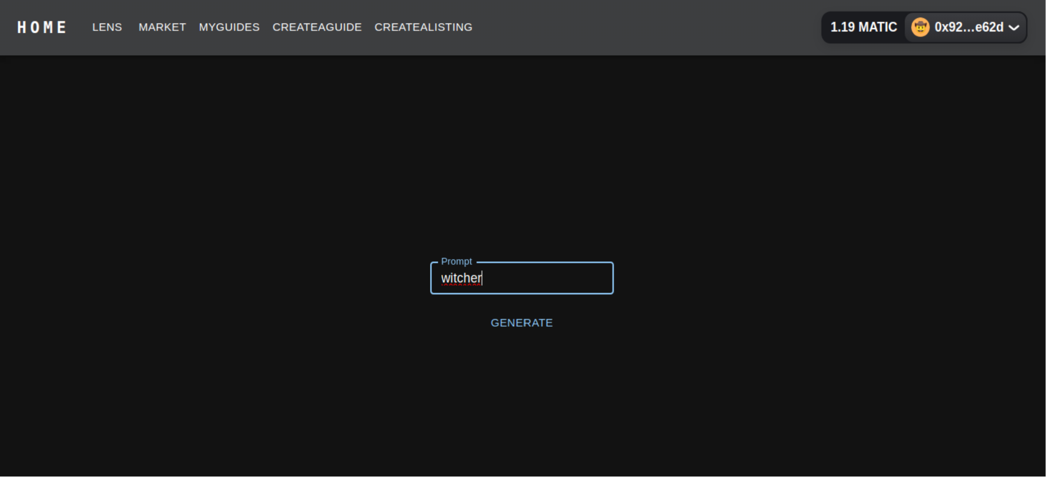

Utilize the text-to-image functionality by inputting the collected listing information into the Stable Diffusion AI tool.

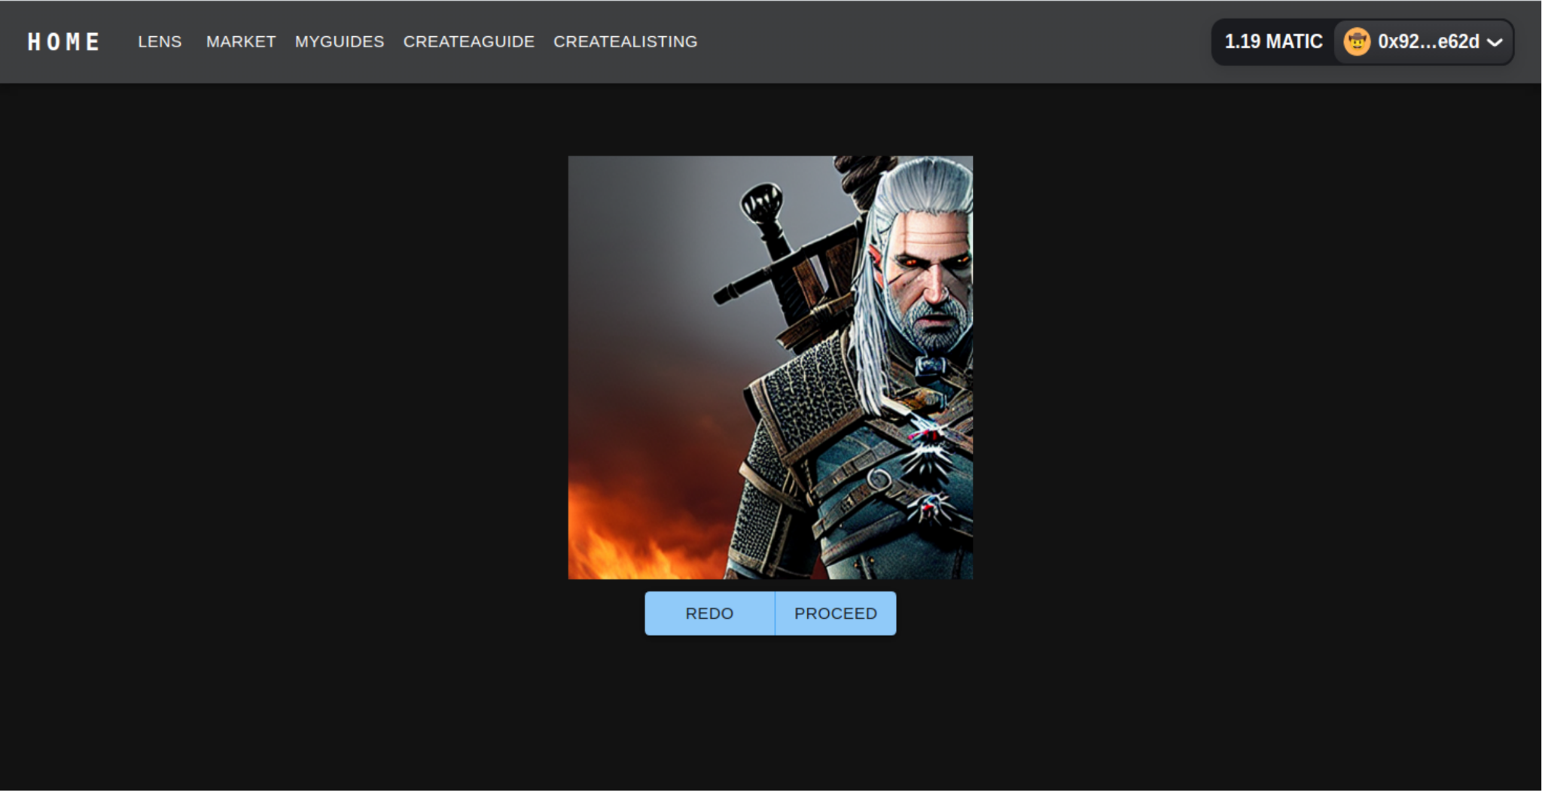

Transforming text into captivating visuals: Enhancing listings with AI-generated images for an immersive user experience and after that minted the image by signing with the help of the metamask

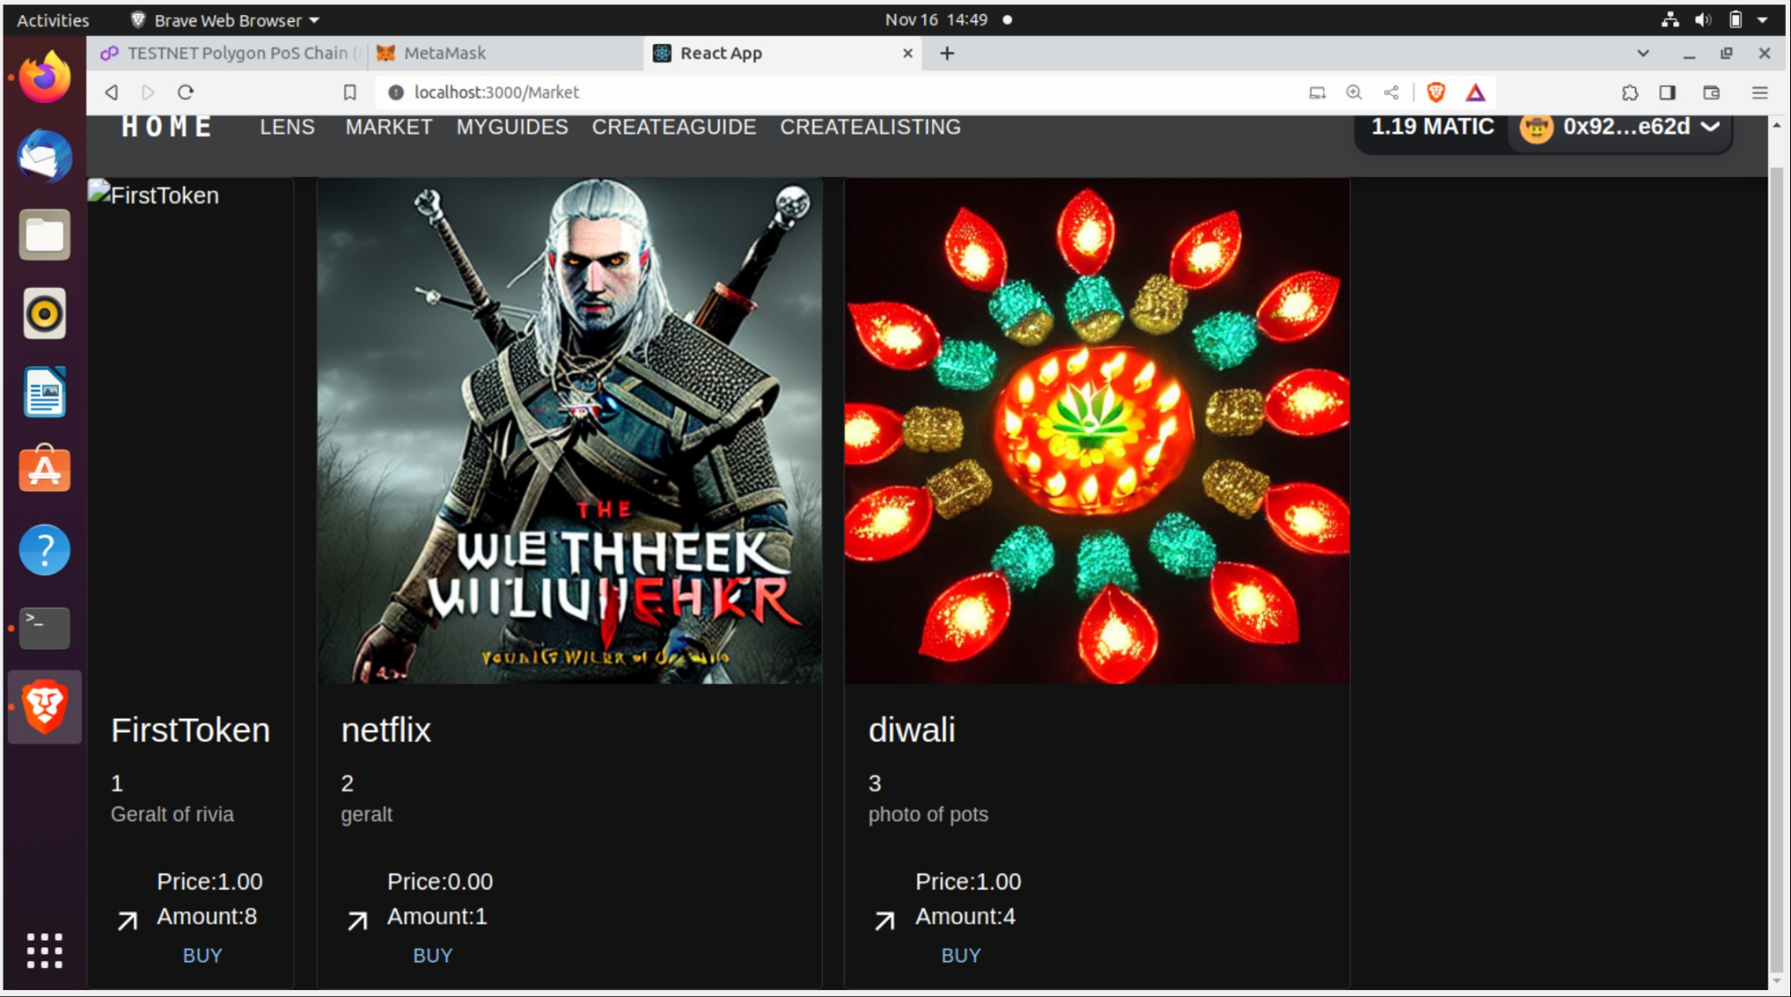

It is the list of all the users' made content in the market for buying in our project's results

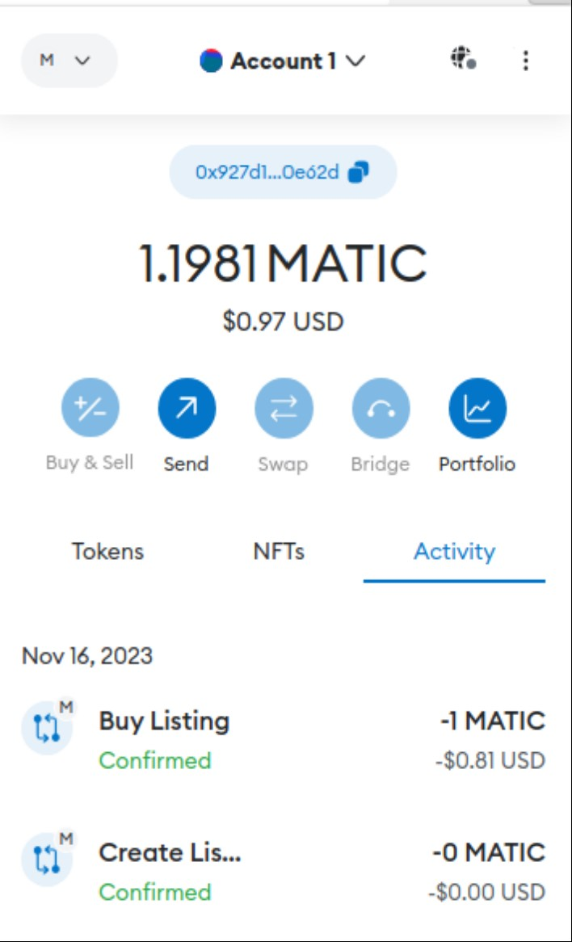

Successfully created and purchased the listed product, completing the transaction with a secure payment.

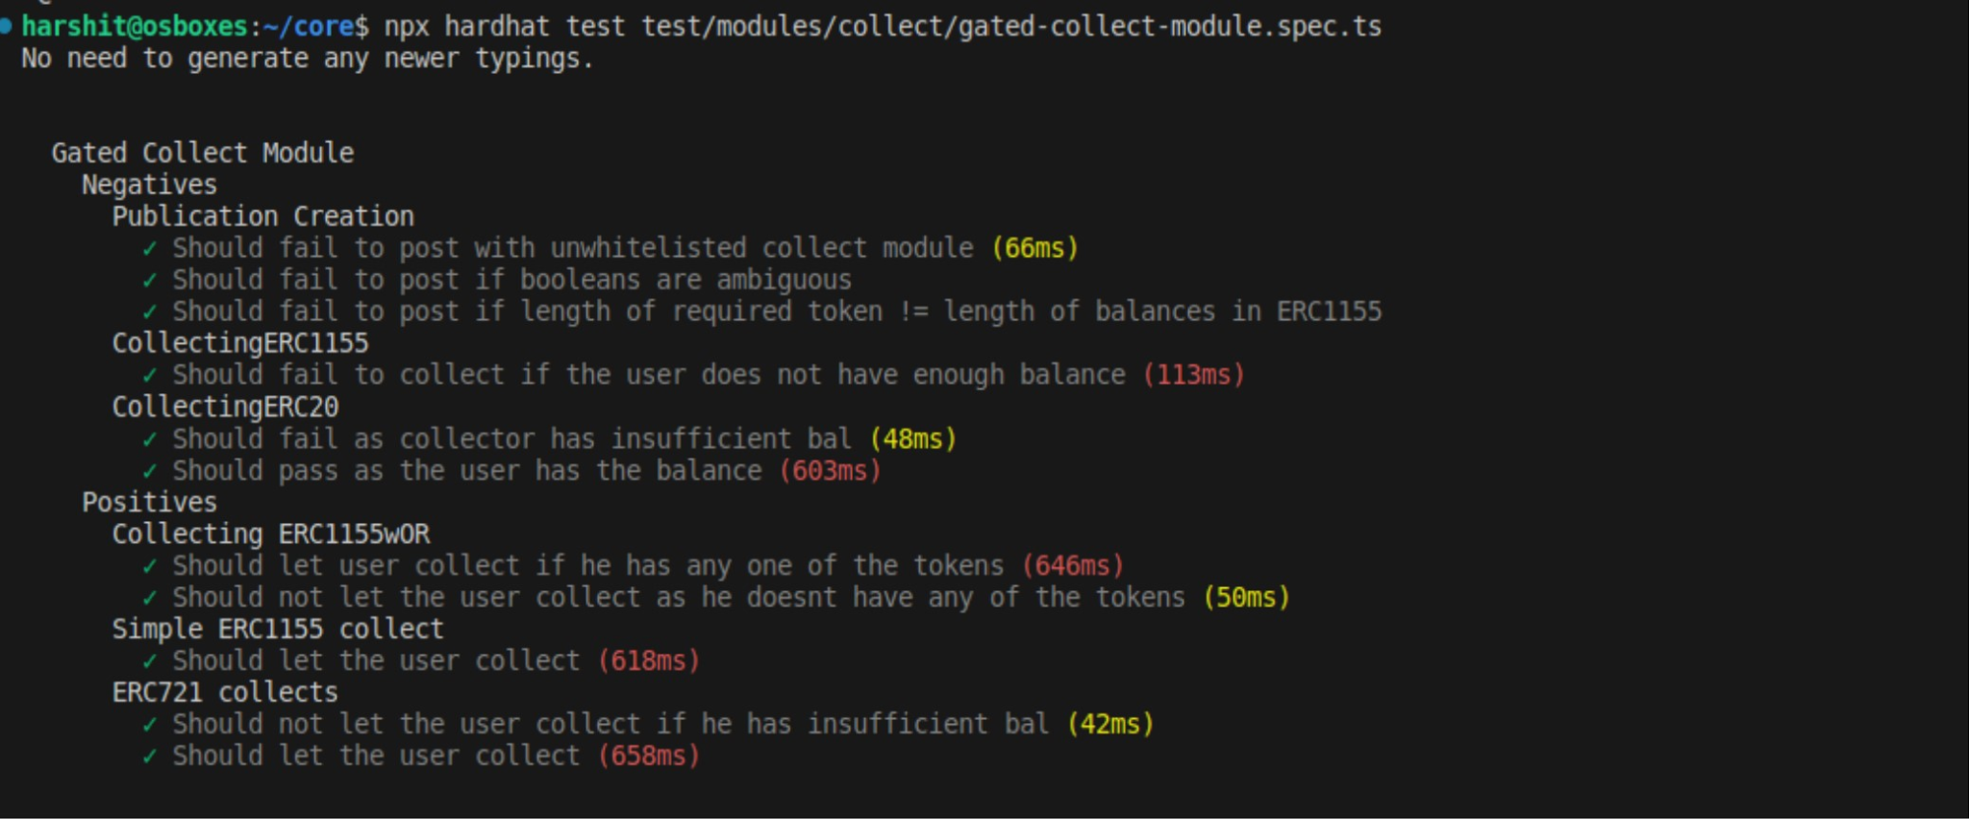

Implemented the 'GatedCollect' Solidity smart contract facilitating controlled access to profile publications. It ensures secure token or NFT collection by validating ownership and balances, enabling controlled access based on specified conditions.

# **Conclusion:**

In a groundbreaking fusion of gasless minting, token gating, and robust anti-spam measures, our project stands as a beacon of innovation and accessibility within the blockchain realm.

By harnessing the power of Stable Diffusion AI for text-to-image generation, we've transcended conventional barriers, enabling users to create captivating listings effortlessly. This breakthrough technology not only enhances the visual appeal of our platform but also streamlines the creation process, empowering users with unprecedented ease and creativity.

Gasless minting, a cornerstone of our initiative, democratizes participation by eliminating transaction fees. This pivotal feature makes engagement inclusive, allowing users to mint assets without financial constraints, fostering a vibrant and engaged community.

Token gating, coupled with stringent security measures, guarantees a fair ecosystem for token holders. It not only rewards engagement but also offers exclusive benefits, nurturing a strong, loyal community invested in the platform's success.

Moreover, our unwavering commitment to a botless, spam-free environment ensures authentic interactions, bolstering trust and fostering genuine engagement among users.

In essence, our project revolutionizes user engagement by marrying innovative AI technology, gasless transactions, and community-driven token gating. It sets the stage for an inclusive, secure, and visually immersive blockchain experience, empowering users to participate, create, and thrive within our vibrant ecosystem.

GITHUB REPOSITORY<https://github.com/harshitkumar007/GROUP7>